**Molendinar**

**Family Learning Centre**

# Early Years Education

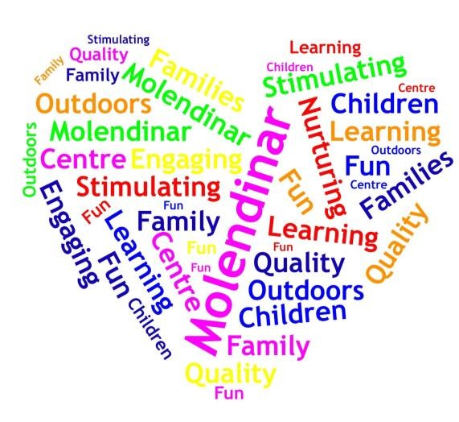

# HANDBOOK

**2024 - 2025 Sharon McLarnon Head of Centre**

**Headteacher@Molendinar-Nursery.glasgow.sch.uk**

**84 Craighead Avenue**

**Blackhill**

**GLASGOW**

**G33 1LH**

Tel: 0141 770 7692

1

**CONTENTS**

**SECTION ONE** **Mission Statement**

* Establishment Aims / Vision
* Non-Denominational Policy
* Equal Opportunities Policy

**SECTION TWO** **General Information**

Names and job titles of our staff members

Times of opening

Age range of children ❖ Keyworker system

Register of applicants.

Enrolment procedures

Settling in

Emergency contacts

Arrival and collection of children

Security

Attendance

Suitable clothing

Outings and consent forms

Insurance

Emergency Closures

Meals, snacks and healthy eating

Education department charges

Fundraising and special events

Provision of toiletries

Smoking

**SECTION THREE Medical Information**

* Medication
* If your child becomes ill
* Minor accidents and upsets

**SECTION FOUR the Nursery Curriculum**

Curricular aims

How we promote learning

Assessment

Supporting children with difficulties ❖ Working together to support learning.

Nursery Developments/Achievements

**SECTION FIVE Parental Services**

Breastfeeding Friendly Centre

**SECTION SIX Other Information**

Child Protection Policy

Links with schools

Accessibility Strategy

Suggestions and complaints

**APPENDICES** 1. Public Holidays and Centre Closures

2. Useful addresses/telephone numbers

**Molendinar Family Learning Centre**

**Vision, Values and Aims**

At **Molendinar Family Learning Centre** our **visions** are:

Provide an environment that is stimulating and engaging for all our learners.

Outdoor learning is available daily and freely accessible for all.

Learning experiences are high quality, fun and offer challenge.

Our families are an integral part of our centre and we offer a range of support to meet their needs.

Values at **Molendinar Family Learning Centre** are:

Motivational staff that support our children and families.

Opportunities for parents, carers, children and staff to reach their full potential.

Learning through play.

Enriching environments that makes a difference to the lives of our children and families.

Nurturing environments.

Devoted staff who understand every child is unique.

Inspiration for our children to learn.

Nurturing, caring staff.

Active and creative professionals who inspire our children to learn.

Reflective, responsible citizens of tomorrow.

Our **AIM’s.**

At Molendinar Family Learning Centre we pride ourselves on ensuring that all children are coming into a loving, caring environment where they are all valued, listened to and respected. We endeavour;

* To create a nursery that provides a safe, happy, caring and secure environment.

* To promote wellbeing and respect.

* To build loving and nurturing relationships to provide an extended family environment.

* To work together with parents as partners to improve learning and care.

* To work in partnership with other agencies and our communities to promote the welfare of our children.

* To raise attainment by engaging our children in the highest quality teaching and learning to maximise success for all.

* To promote a culture of inclusion, diversity, equality, fairness and opportunity.

* To value and empower our children and Practitioners by recognising and celebrating successes and achievements.

## Non-Denominational Policy of the Centre

The centre is non-denominational. We respect and welcome children and parents/carers of all religions, faiths and beliefs.

**Our Equal Opportunities Policy**

Molendinar Family Learning Centre is committed to promoting equal opportunities and be anti-racist, anti-sexist, multi-cultural and recognise the rights of both men and women to work or to care for children. Provision should take account of the needs of children with additional support needs or chronic illnesses. These principles are reflected in the criteria used to admit children to the centre and in the curriculum of all the establishments. The Centre is committed to providing race equality to all children and their families who have equal access to verbal and written communication. We aim to promote equality and ensure that racism has no place in the Centre. The nursery caters for both boys and girls.

### Section Two

**Names and Job Titles of Our Staff Members**

#### GENERAL INFORMATION

##### Names and Job Titles of Our Practitioners Members

|  |  |  |  |
| --- | --- | --- | --- |
| **Senior Management Team: -** | |  |  |
|  | Sharon McLarnon |  | Head of Centre |
|  | Susan Murdoch |  | Deputy Head of Centre (Job Share) |
|  | Jacqueline Smyth |  | Deputy Head of Centre (Job Share) |
|  |  |  | Team leader Part time |
|  | Irene Muldoon |  | Team Leader |
|  | Lara Purvis |  | Lead Practitioner of Attainment |
|  |  |  |  |
| **Clerical Team: -** | |  |  |
|  | Sharon Ford |  | Clerical Assistant (Part-time) |
|  |  |  |  |
|  |  |  |  |
| **Child Development officers: -** | |  |  |
|  | Kirstine Bell |  | Child Development Officer |
|  | Colette Bovill |  | Child Development Officer |
|  | Emma Crooks |  | Child Development Officer (Job Share) |
|  | Jade Coulter |  | Child Development Officer |
|  | Emma Faulkner |  | Child Development Officer |
|  | Janet Hillhouse |  | Child Development Officer |
|  | Amy Black |  | Child Development Officer |
|  | Karen Kerr |  | Child Development Officer |
|  | Susan Millar |  | Child Development Officer |
|  | Gillian McCulloch |  | Child Development Officer |
|  | Danielle McCorquodale |  | Child Development Officer |
|  | Gemma McQaude |  | Child Development Officer |
|  | Shanisse Wilson |  | Child Development Officer |
|  | Jennifer Scambler |  | Child Development Officer |
|  | Robyn Priestley |  | Child Development Officer |
|  | Margaret Scott |  | Child Development Officer (Job Share) |
|  | Lauren Smith |  | Child Development Officer |
|  | Nicola Thom |  | Child Development Officer |
|  | Katherine McCudden |  | Child Development Officer |
|  | Natalie Thompson |  | Child Development Officer |
|  | Skye Hughson |  | Child Development Officer |

|  |  |  |  |
| --- | --- | --- | --- |
| **Support for learning team: -** | |  |  |
|  | Samantha McKay |  | Support for Learning Worker |
|  |  |  |  |
|  |  |  |  |
|  |  |  |  |
| **Janitorial, cleaning and catering team: -** | | |  |
|  | Derek Ross |  | Janitor |
|  | Jean Gannon |  | Cleaning Supervisor |
|  | Hugh McGuire |  | Cleaner |
|  | Amanda Lowe |  | Cleaner |
|  |  |  |  |
|  | Elaine White |  | Catering Assistant |
|  | Akli Bouakkaz |  | Catering Assistant |
|  |  |  |  |

Molendinar Family Learning Centre from time to time may accommodate students from Early Learning, Childcare or Nursing.

All practitioners are fully qualified and registered with the Scottish Social Services Council and all registrations can be checked on their website.

**Duty of candour statement**

Dear service users,

The duty of Candour is a statutory duty to be honest with all service users and their Parents/ families or carers when something goes wrong that appears to have caused or could lead to significant harm in the future.

This means the staff and management in Molendinar Family Learning Centre must:

* Tell the parents (or carer) of a child when something goes wrong.
* Apologise to the parent (or carer).
* Offers an appropriate remedy or support to put the matter right (If possible).
* Explain fully to the parent (or carer) the short- and long-term effects of what has happened.

Molendinar Family Learning Centre has a duty to provide an annual Duty of Candour statement.

The management team has a commitment to undertake Duty of Candour Training and raise awareness of this legislation within the entire team.

I you require any further information regarding the Duty of Candour legislation please speak to a member of the management team.

Kind regards

Molendinar Family Learning Centre Senior Management Team

##### TIMES OF OPENING

Currently the Centre is open from 8:00am until 5.45pm, Monday to Friday, 50 weeks of the year, except for public holidays, in-service training days and COVID – 19 restrictions on service. Details of these closures can be found in appendix three at the end of this handbook. Each child’s times of attendance vary within these hours and are allocated based on needs.

**AGE RANGE OF CHILDREN**

The Centre has provision for children aged 6 months to 5 years.

##### KEYWORKER SYSTEM

Each child has their own key worker within their playroom. Their dedicated key worker and other staff within the play room, will work together to support your child’s needs, personal care, wellbeing, and development, whilst working with you to ensure that maximum benefit is gained from attending the nursery.

##### REGISTER OF APPLICANTS

A register of applicants will be kept by the Head of Centre. Each application will be prioritised for admission in accordance with Glasgow City Council policy, considering each family’s circumstances. Parents may ask to see their application at any time and any changes of circumstances that may affect your application must be notified to the Head of Centre.

##### ENROLMENT

When a place becomes available for your child, we will contact you regarding the enrolment procedures. There will be a meeting for new parents to which you will be invited ensuring we all parties follow National and local guidelines on face coverings (except exceptions), 2-meter distancing, hand washing/hand sanitizing and completion of Glasgow City Council’s track and trace form.

**Glasgow City councils charging policy.**

When your child is allocated a nursery placement there are charges which may apply. In line with Glasgow City Council policies, you will be asked to verify your circumstances i.e., proof of employment, benefits, address etc and the charges will be levied according to your personal family circumstances. In order that we provide nursery provision to meet your requirements, you will be asked for this information every 6months. Please note, failure to provide this documentation could result in a review of the offer of the nursery placement. For further information, please refer to the Information for Parents/Carers on Charges in Glasgow City Council Nurseries provided at enrolment day.

## Charges rates for August 2024 - 2025

|  |  |
| --- | --- |
| Glasgow resident standard rate from age 3-5 years | £5.50 Per hour |
| Glasgow resident standard rate from age 0 - 3years | £4.00 Per hour |
| Discounted hourly rate 3-5-year olds | £4:50 per hour |
| Discounted hourly rate 0- 3 years olds | £3:00 per hour |
| Glasgow resident reduced rate and  Kinship carer rate | £1:00 per hour |
| Glasgow resident first child rate 35 years.  Glasgow resident first child rate 0-  3 years  Glasgow resident second child rate  Glasgow resident third child rate | £5:50 per hour    £4.50 per hour    £2.20 per hour  £1.70 per hour |
| Glasgow resident College/  University rate | £ 5:50 for 3-5-year olds  £4:50 for 0-3-year olds |
| Non-Glasgow Resident rate | £5:50 per hour |
| Lunches | £1.52 (per meal) |

All charges, including those for meals and snacks are subject to review and any changes will be notified to parents/carers by the head of your early year’s establishment.

Charges are paid directly to Glasgow City Council and in advance. How to pay for your child’s Early Years education is contained in the Information for Parents/Carers on Charges in Glasgow City Council Nurseries provided at enrolment day.

### CONDITION OF PLACEMENT FORM

You will be required to complete a Condition of Placement Form for your child. All places allocated will be subject to a six-monthly review at which the Head of Centre will have the right to modify the placement offered or charges levied. This review will consider any changes in circumstance. Any changes agreed at this review will be implemented in the following school term.

Should your circumstances change within the six-month period you should notify us in writing giving a four-week period of notice.

### SETTLING IN

On the first day that you bring your child you will be welcomed by your keyworker and you will be asked to stay with your child for an hour so that the introduction is a gentle one. We will have some forms for you to fill in while your child can play and familiarise themselves with the new surroundings and faces. As the days pass you will have the opportunity to leave your child in the care of his/her keyworker for increasingly longer periods of time and your child’s hours of attendance will lengthen. There is no set formula or time span for this as all children react differently to separating from their parents or carers.

### EMERGENCY CONTACTS

You will be asked to provide the establishment with the names, addresses and telephone numbers of two contact persons for use in the case of emergency. Please bring those persons to the Centre to be introduced to the Practitioners at the earliest opportunity and keep us up to date as to changes to their details.

### ARRIVAL AND COLLECTION OF CHILDREN

It is expected that a responsible adult, aged 16 years or over, will always bring and collect your child. If you or the person expected to collect your child have been delayed, please make every effort to let us know. We operate a password system which you will be requested to set up at the beginning of your child’s settling period. Children cannot be allowed to leave with any person who is a stranger to the Practitioners under any circumstances and children will only be released if the correct password is given. If no-one arrives to collect your child, we will try to get in touch with you and then your emergency contacts. If no-one can be contacted and your child is still here when the Centre is due to close, we will have to contact the Social Work Department so that your child can continue to be cared for until you are located.

### SECURITY

The centre operates a security entry system. Please press button at the main door to alert a member of staff if the main office is unmanned to gain entry. Always close the door firmly behind you and do not let any adults who are not in your company enter as you come in or leave, as they may not be known to Practitioners and therefore require to be met at the door. Whoever brings or collects a child from the Centre must sign them in and out (a procedure which will be explained during the settling in period).

### ATTENDANCE

Due to pressure on places, we cannot hold a place open for a child who does not use it. Please let us know straightaway if you no longer require a place. If your child is off for more than a couple of days owing to illness or holidays let us know when she or he will be returning. When a child has been absent for a two-week period with no explanation, we will try to get in touch with a parent or carer by telephone or letter. If no contact can be made or no response is forthcoming, then that child’s place will be reallocated at the earliest opportunity.

### SUITABLE CLOTHING

Children have fun doing messy work and, although we encourage them to wear aprons, clothes are often affected so please do not bring children to nursery in their best outfits. A change of clothing can be kept in each child’s bag on their peg (several changes if in the throes of toilet training please). Please note that we cannot ban any child from

participating in any activity on any grounds other than medical or religious ones as we are bound to provide every child with as broad and balanced a curriculum as we can. Soft shoes are best worn to nursery to avoid accidental injury and aid physical play

and outdoor clothing suited to the weather in case outdoor play or a trip is planned.

Please note due to health and safety reasons Glasgow City Council recommends children should not wear jewellery of any type to nursery. We currently have a risk assessment in place and if you wish please request to read it.

### OUTINGS AND CONSENT FORMS

When trips are planned you will be informed in advance and asked to complete a consent form giving your permission for your child to attend the trip. No child can be included in such a trip without this form having been completed. However, consent for local outings and excursion is

encompassed in the enrolment forms.

### INSURANCE

Children are insured whilst on a nursery trip for which your consent has been obtained but the City Council will accept no responsibility for loss of or damage to clothing or personal belongings either Inside or outside of the Centre.

### PRAM SHED

For your convenience there is a pram shed located to the side of the school entrance. You are welcome to leave your pram here whilst your child is in nursery. Prams are left at your own risk; the nursery can accept no responsibility for lost or stolen prams from this area. (Our prams shed is temporarily out of use due to needing repaired we are working on getting this up and running as soon as we can).

### EMERGENCY CLOSURE ARRANGEMENTS

On occasion it may be necessary to close the building at short notice. This could be due to power failure or severe weather conditions, etc. If this happens, we will do our best to let you know what is happening. We may keep in touch by telephone, letter, and notices in local shops and community centres and/or through announcements in local churches, the press or on radio. Remuneration of charges will be decided at a later date.

### MEALS, SNACKS AND HEALTHY EATING

Meals are supplied by GCC. Menus are based on low salt, low sugar and low-fat foods and reflect a balanced diet. Snacks are also provided; we do have a weaning menu that is also in place at the centre. We are also aware that when

first weaning your child, you may wish to provide small snacks or lunch until your child becomes more confident. Please ensure this is discussed with your child’s keyworker and are provided in the original sealed packaging or tubs as we cannot accept opened containers or homemade food due to health and safety regulations and Glasgow city council polices They also have to be in line with the guidance from NHS Health Scotland document ‘Setting the Table’. Practitioners are not liable for foods already prepared by the parent/carer.

### HEALTHY SNACKS POLICY

Molendinar Family Learning Centre is a **SMILE NURSERY.**

Our Aims:

* To reduce the intake of sugary foods.
* To promote regular teeth cleaning with a fluoride toothpaste.
* To promote a healthy nutritious diet.
* To promote cut up fruit and vegetables as a snack food.
* To give children milk or water as drinks at the centre.
* To promote early registration with a family dentist.
* To reduce children’s tooth decay.

### BIRTHDAYS

A small store-bought sponge cake is all you have to bring to the centre. Please discuss this with your child’s keyworker. Every child will receive a book and a birthday card when they attend the

nursery on their special day.

### EARLY YEARS CHARGES

Charges are paid directly to Glasgow City Council and in advance. You will be provided with an Early Years Admissions and Charges booklet, outlining how the charges are calculated.

### FUNDRAISING

Some things are not provided for by our Council funding. For example: birthday/Christmas presents, outings and trips. For this reason, we ask parents to contribute to our toy fund, currently £2.00 a week for one child and £3.00 for two children. It is also sometimes necessary to fundraise for specific purposes. We may ask you to participate in selling raffles, auctions, sponsored activities and suchlike from time to time.

### PROVISION OF TOILETRIES

Our budget doesn’t extend to providing these items for your child so please bring with you your own nappies/wipes/creams/sunscreen as required.

### SMOKING

Please note that, in accordance with the law smoking is not permitted within the building or anywhere else within the premise’s boundary.

**Section Three**

### MEDICAL INFORMATION

#### MEDICATION

If your child requires medication during her/his time at nursery this must be arranged in advance and relevant forms completed. Note that only prescribed medication can be given, from the container with the prescription label on it. The first dose of any medication even if this is previously prescribed must be administered in front of practitioners or at home. If your child has a specific health need, then you will be asked to fill in a health care plan specific to your child’ needs.

Please note whilst every effort will be made to administer medicines to your child, at times this may not be possible, as there is a limited number of practitioners within the building administer medication.

#### IF YOUR CHILD BECOMES ILL

We would welcome a call from you if your child were unable to come to nursery due to illness. Should he or she become ill whilst at the nursery, we will firstly try to contact the parent before telephoning one of your emergency contacts.

However, working parents may prefer us to contact their first emergency contact thus allowing them to remain at work. During your enrolment, please make it clear who should be contacted in the first instance.

If the illness seems serious, medical advice will be sought without delay – you will have been asked on the enrolment form if you consent to emergency medical/dental treatment – but we will continue trying to contact a child’s family until they are reached. If your child will be absent from nursery, we request that parents/carers contact the nursery to report their child’s absence and the reason for this by calling the nursery directly and leaving a message with our clerical assistant of a member of the management team.

#### MINOR ACCIDENTS AND UPSETS

Occasional bumps and bruises are inevitable when children play together

anywhere. Should your child sustain an injury here then this will be recorded on an accident form. The parent/carer will be required to sign the accident. In the event that an injury/illness seems serious, then those steps outlined above for illness will be followed. However, if the injury/illness is very serious then the nursery would seek medical advice and try and contact you.

**Section Four**

### THE NURSERY CURRICULUM

#### CURRICULAR AIMS

Practitioners seek to:

* + - * Develop self-esteem in every child.
      * Empower each child with the attitudes, skills and understanding necessary to promote effective learning.
      * Foster achievement.
      * Encourage the development of positive interpersonal relationships.

#### HOW WE PROMOTE LEARNING

##### Our Curriculum Document – Pre- Birth to Three National Guidance

Our under 3’s curriculum is based around the positive outcomes contained in this document. The pre- birth to three curriculum links later with the underpinning values of the 3-18 Curriculum for Excellence.

The key principles of the Pre- Birth to Three documents underpin the:

* + - * Rights of the Child
      * Relationships
* Responsive Care
* Respect

There are also guidelines around Practitioner’s roles and responsibilities and considers all aspects of care in the care setting.

There will be a copy of these documents on display within the centre and a hyperlink on our nursery website if you should wish to look.

#### A CURRICULUM FOR EXCELLENCE

The Curriculum for Excellence’s underpinning values is wisdom, justice, compassion, and integrity with the child at the centre of learning.

The purpose of the curriculum is to enable the child to develop the “four capacities”.

To enable all children to become:

* *Successful Learners*
* *Confident Individuals*
* *Responsible Citizens*
* *Effective Contributors*

The curriculum is inclusive and a stimulus for personal achievement and by a broadening of experience of the world is an encouragement towards informed and responsible citizenship.

Experiences and outcomes set out expectations for learning and development in:

* Expressive arts
* Language and Literacy
* Health & Well- being
* Mathematics & Numeracy
* Religious & Moral Education
* Sciences
* Social Studies
* Technologies

The experiences and outcomes in the range of curriculum areas build in relevant attributes and capabilities which support the development of the four capacities.

#### Realising the Ambition. National Practice Guidance for early years in Scotland access [Here](https://education.gov.scot/improvement/learning-resources/realising-the-ambition/) Children and Young People (Scotland) Act 2014 access [Here](https://www.legislation.gov.uk/asp/2014/8/contents/enacted)

‘Our expansion of early learning and childcare is ambitious – and rightly so – with quality at its heart. This guidance is designed to support practitioners in their important role to deliver high quality early learning and childcare which is accessible and affordable for all children and families. It has been developed in partnership and tested with practitioners and is intended to support the increasing knowledge and skills required through training, practice, continual personal development and reflection, alongside supporting quality assurance and improvement.’ Marie Todd. (Minister for Children and Young People.)

#### How Good is our Early Learning and childcare? Education Scotland

This is a Self-Evaluation Framework Document to help in the process of self-evaluation for settings to improve their quality and aim for excellence. We seek to build on a positive response but at the same time take a fresh look at the developing needs and reflect the changes and increased provision of the Early Learning and Childcare sector today.

For further information about these documents please feel free to speak to your child’s key worker. When talking about the curriculum offered in the centre it is important to reiterate that we value all the knowledge that your children bring to us. They have already learned a great deal about the world around them before coming to the centre. We use this knowledge to build on your child’s learning in the centre. Practitioners will be glad to talk to you about what your child is learning in the centre, both informally and formally. We recognise the value of working with you to contribute to all that you are already doing to give your child the best possible start in life.

#### ASSESSMENT

Each child is respected and recognised as an individual. As every child is unique in their prior experience, knowledge, and personality, we observe each child in order to get to know their abilities and characters in depth and to provide us with enough knowledge to tailor the curriculum to their needs and interests. Progress will be recorded, and records shown to and discussed with parents regularly.

#### SUPPORTING CHILDREN WHO REQUIRE ADDITIONAL SUPPORT FOR LEARNING

You or your child’s keyworker may be aware that your child has difficulties in some areas of development. Either way we can work together to help overcome any challenges. Occasionally it may be helpful to involve another professional’ such as a speech therapist or educational psychologist but would be fully discussed with parents and consent obtained before a referral could be made should this seem the best way forward. If you have any concerns about your child at all, please feel free to arrange an appointment with his/her key worker.

#### WORKING TOGETHER TO SUPPORT LEARNING

In any circumstances it is you who knows your own child best and is the primary educator. It is helpful for Practitioners to be made aware of children’s preferences, interests and experiences at home so that they can build upon that. Similarly, you will be kept informed (by notice, newsletter, letters and displays as well as through conversation) of what your child has been doing and learning here and, of course, learning is much enhanced if it is reinforced at home too.

Consistency is the key to effectiveness, especially in matters of behaviour, so let’s work as a team to enable your child to make the most of his/her time here.

#### NURSERY GROUPS

In nursery there are various groups that you may be asked to join, for example:

* We have a parent committee.
* Fundraising – parents are asked to help in all aspects of fundraising.
* Molendinar Family Learning Centre has recently delivered several PDA courses in conjunction with Love Learning Scotland.

#### Communicating with Parents/Carers

We use various methods to keep parents/carers up to date with what’s happening in the nursery and Special Events e.g., Posters, newsletters, text messaging etc.

We also use Social Media Facebook for which you will be able to access information in regard to events and nursery developments (we do not post pictures of our children or families on our page).



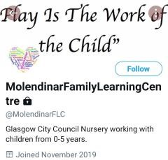

Twitter

Look for Molendinar Family Learning Centre and our logo.

Nursery website: - Our Nursery website now live and can be accessed at this web address <http://www.molendinar-nursery.glasgow.sch.uk/>

##### Achievements/ Recent Developments

Molendinar has developed its gardens to promote outdoor learning, we actively encourage young children to access outdoors, daily the grounds are set up to promote children’s health & wellbeing, literacy, and numeracy skills whilst they are taking part in outdoor play. We have gained £10,000 in 2017 from The Big Lottery to further develop the grounds.

In our School Improvement Plan we are focusing on Literacy with a priority of taking forward Phonological Awareness, Digital Learning throughout the nursery and Self-Evaluation to ensure we are using effective systems to gather evidence from service users to improve our nursery.

### Section Five

*Breast Feeding Friendly Nursery*

*Molendinar Family Learning Centre will actively promote breastfeeding, in line with the needs of mothers and their*

*families and promote an environment where breastfeeding is seen as the normal way to feed babies.*



**Section Six**

### OTHER INFORMATION

We would like to take this opportunity to advise you that Glasgow City Councils Health and safety Code of practice states that “Personal effects (e.g., jewellery, body piercings, items of Religious significance, watches, hair slides and belts constitute a hazard and may cause injury if worn whilst participating in physical education and **MUST BE REMOVED.”** In February 2013 early years and Health and safety agreed that Physical education is a large part of the early years Curriculum offered several times a day and that this would-be risk assessed about wearing personal effects such as, jewellery, earrings, necklaces, bangles, rings, watches and large hair slides. Glasgow City Council recommends that they are not worn within Molendinar Family Learning centre. Risk assessment is available in main office if you wish to view it.

**No child will be permitted to access the centre under any circumstances when wear hooped or dangly earrings regardless of risk assessment.**

#### CHILD SAFETY/CHILD PROTECTION POLICY

All educational establishments and services must take positive steps to help children protect themselves by ensuring that programmes of health and personal safety are central to the curriculum and should have in place a curriculum that ensures that children have a clear understanding of the difference between appropriate and inappropriate behaviour on the part of another person, no matter who.

The health and personal safety programme for your child’s establishment will be fully discussed with you on a regular basis.

Schools, establishments, and services must create and maintain a positive ethos and climate which actively promotes child welfare and a safe environment by:

* Ensuring that children are respected and listened to.
* Ensuring that programmes of health and personal safety are central to the curriculum.
* Ensuring that Practitioners are aware of child protection issues and procedures.

Establishing and maintaining close working relationships and arrangements with all other agencies to make sure that professionals collaborate effectively in protecting children.

Should any member of Practitioners have concerns regarding the welfare or safety of any child they must report these concerns to the head of establishment. The head, or the person deputising for the head, after judging that there may be grounds for concern regarding the welfare or safety of any pupil must then immediately advise the duty senior social worker at the local social work services area office of the circumstances. At Molendinar we have two child protection co-ordinators.

* Sharon McLarnon: - child protection coordinator
* Susan Murdoch, Jaqueline Smyth and Irene Muldoon: - deputising child protection co-ordinators

The role of the child protection officer is to attend and update child protection training annually for all Practitioners and students within the centre.

To ensure the child protection procedures are sign posted throughout the centre for all stakeholders.

Copies of departmental guidelines (Management Circular 57) are available from the Head of centre on request.

##### Car parking

Car parking facilities are not available at the nursery grounds and vehicles must be parked outside the grounds on the main street. If you chose to park on the spare ground opposite the nursery car park you do so at your own risk. This land is privately owned. Glasgow City Council will not be held liable if any accidents/ incidents occur.

**Appendix 9**

MANAGEMENT CIRCULAR No.57

01

/

09

18

**Child Welfare and Safety**

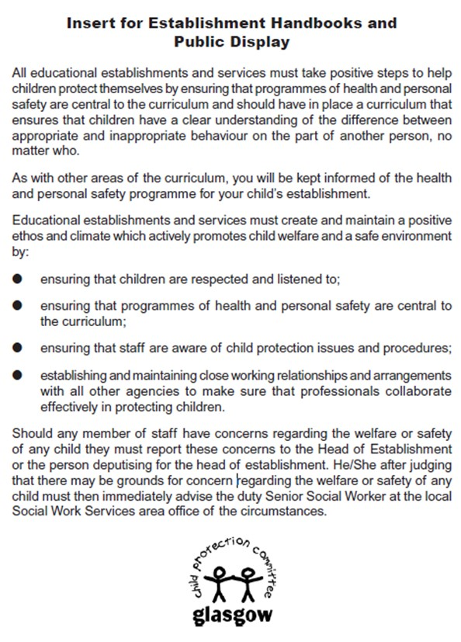

**TO ALL PARENTS AND CARERS.**

PLEASE SWITCH OFF **ALL** MOBILE PHONES WHEN IN THE BUILDING.



**NO** PICTURES TO BE TAKEN IN

NURSERY UNLESS AUTHORISED BY A MEMBER OF THE NURSERY MANAGEMENT TEAM.

Thank you.

#### LINKS WITH PRIMARY SCHOOLS

The centre has links with St Philomena’s, Carntyne, St Thomas’ and Wallacewell. We will be able to let you know when their enrolment and induction days for new primary one’s are and infant teachers may visit the Centre to meet their new pupils too, in order to make the transition from nursery to primary school as smooth as possible. Transition records, which outline for the infant teacher a new primary one child’s prior learning, are passed onto their schools, with parents having been given the opportunity to read and comment on them first. **We will endeavour to support you in any way we can with your child’s transition to primary however, the enrolment of your child in primary school remains the responsibility of Parents, carers and/or legal guardians.**

#### ACCESSIBILITY STRATEGY

Standard Statement

The centre has a duty to ensure that all our pupils have equal access to the curriculum, supported as appropriate to their individual needs. This covers not only the content of lessons and teaching strategies but also minor adaptations to the physical environment of our building to address the needs of pupils with physical or sensory impairments, including the relocation of classes to the ground floor where feasible.

We also need to ensure that parents who have a disability have equal access to information about their children. This could involve, for example, relocating the venue for parents’ meetings to facilitate physical access at parents’ evenings or individual interviews; provision of an interpreter for the deaf; agreeing a telephone contact system to provide direct feedback to parents.

##### SUGGESTIONS AND COMPLAINTS

In the first instance speak to Sharon McLarnon Head of Centre or another Manager on Duty.

##### Complaints Procedure

If you have a complaint, please contact the Head of Centre in the first instance who will investigate matters and report back to you within 5 days. (You may call in person, write, telephone or email)

If you feel unable to do so or your complaint remains unresolved you may then Contact

Customer Liaison Unit

City Chambers – East Building

Glasgow City Council

40 John Street Glasgow

G1 1JL

Telephone 0141 287 5384

Who will:

* Take a totally neutral stance in fully investigating your complaint.
* Acknowledge receipt of your complaint within five working days.
* Give a full written response within a further 10 working days unless another timescale has been agreed.

The Customer Liaison Unit can be contacted by phone or e-mail.

Phone 0141 287 5384

Email education@glasgow.gov.uk

If you do not wish to contact Glasgow City Council directly you may instead contact:

The Care Inspectorate checks that the service meets the Health & Social Care,

My Support, and My Life. Published by the Scottish Government (2017)

You may contact the Care Inspectorate in person, in writing, by e-mail or by telephone at Care Inspectorate

Compass House

11 Riverside Drive

Dundee

DD1 4NY

01382 207100

Fax 01382 207289

[www.careinspectorate.com](http://www.careinspectorate.com/)

Email: enquiries@careinspectorate.com Enquiries 0345 6009527

**ADDRESSES AND CONTACTS**

Mr Douglas Hutchison Jackie Fulton

Service Director Area Education Officer Education

Education Services Education Services

|  |  |
| --- | --- |
| Glasgow City Council | Glasgow City Council |
| City Chambers East Building | City Chambers East Building |
| 40 John Street | 40 John Street |
| Glasgow | Glasgow |
| G1 1JL | G1 1HL |
| Easterhouse Police Station | 0141 532 4300 |
| Easterhouse Sports Centre | 0141 276 1630 |

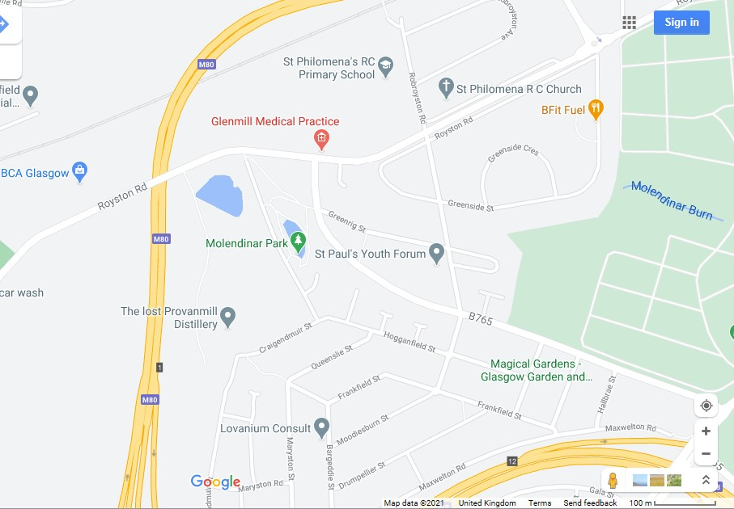

**We are**

**here.**

Buses:

19

and 38C will drop you of at Royston road across from Glenmill medical

centre or Provanmill shops.

### GFIS (Glasgow Family Information Service)

[**www.gfis.org.uk**](http://www.gfis.org.uk/)

This site offers advice with regards to admissions, childcare charges, accessing childcare etc

Early Childhood and extended Childcare Services

40 John Street’

G1 1JL

0141 287 4702



### Appendix 1

**CENTRE CLOSURES 2024 – 2025**

|  |  |
| --- | --- |
| **August** | **In Service Days – Closed to ALL children**  Monday 12th & Tuesday 13th  **ALL children return** on Wednesday 14th |
| **September** | **September Weekend**  Closed to ALL children (September Weekend)  Friday 27th  Monday 30th |
| **October** | **In Service Day – Closed to ALL children**  Friday 11th  **October Week**  **Term Time** children only  Monday 14th to Friday 18th |
| **December** | **Christmas and New Year**  **Term Time** Children Only – 2.30pm Friday 20th  **ALL** Children – Monday 23rd to Friday 3rd January |
| **January** | **ALL children return** on Monday 6th |
| **February** | **In Service Day – Closed to all children**  Wednesday 19th  **Mid-Term Break**  **Term Time** children only  Monday 17th & Tuesday 18th |
| **April** | **Spring Break (Easter)**  **Term Time** children only  2.30pm Friday 4th  Monday 7th to Monday 21st |
| **May** | **In Service Day – Closed to ALL children**  Thursday 22nd  **Bank Holidays – Closed to ALL children**  Monday 5th  Friday 23rd to Monday 26th |
| **June** | **Summer Holidays**  **Term Time children only**  Wednesday 25th at 1pm |

**Appendix 2**

**USEFUL ADDRESSES/TELEPHONE NUMBERS**

### Director of Education Services

Mr Douglas Hutchison

Education Offices

City Chambers

40, John Street

Glasgow

G1 1JL

### Early Childhood and Extended Services

Centenary House

100 Morrison Street

Glasgow

G5 8LN

### Social Work Department

Westwood House,

1250 Westerhouse Road, Glasgow G34 9EA.

Tel 0141 276 3400